**23CSE111**

**OBJECT ORIENTED PROGRAMMING**

**LAB REPORT**



**Department of Computer Science Engineering**   **Amrita School of Computing**

**Amrita Vishwa Vidyapeetham, Amaravati Campus**

**Name: M.SRIMANTH**

**Roll No: AV.SC.U4CSE24228**

**Verified By :**

**INDEX**

WEEK-1

|  |  |  |  |
| --- | --- | --- | --- |
| **S.NO** | **Program** | **Page No** | **Date** |
| **1** | **Installation Process of JDK** | **3-4** |  |
| **2** | **Simple java program for**  **printing basic details of student** | **4-5** |  |

WEEK-2

|  |  |  |  |
| --- | --- | --- | --- |
| **S.NO** | **Program** | **Page No** | **Date** |
| **1** | **Java program for calculating simple interest** | **6-7** |  |
| **2** | **Java program for calculating area of rectangle** | **7-8** |  |
| **3** | **Java program for calculating area of Triangle** |  |  |
| **4** | **Java program for calculating Fibonacci series** |  |  |
| **5** | **Java program to convert temperature from Fahrenheit**  **to Celsius** |  |  |

WEEK-3

|  |  |  |  |
| --- | --- | --- | --- |
| S.NO | Program | Page No | Date |
|  |  |  |  |
|  |  |  |  |

# WEEK-1

1. **Installing Java Development Kit (JDK) :**
   1. **Download JDK:**

* Go to the Oracle JDK download page in google and click on JDK-21 version which is Long term support (LTS) version.
* Click the download link as your operating system (Windows, macOS, or Linux).
  1. **Install JDK:**
* Once downloaded, run the installer.
* Follow the given instructions and keep clicking "Next" until it is done.
  1. **Set Environment Variables (Windows):**
* Open file explorer, then right click on This PC next select on properties then it will take you to the settings app then click on advanced system settings and then click on **Environment Variables**.
* Click on path and new under **System Variables**:

**Variable value:** The folder address where JDK is installed (like

C:\Program Files\Java\jdk-21\bin)

* Find Path under **System Variables**, click **New**, and add the path of the jdk-21(C:\Program Files\Java\jdk-21\bin)

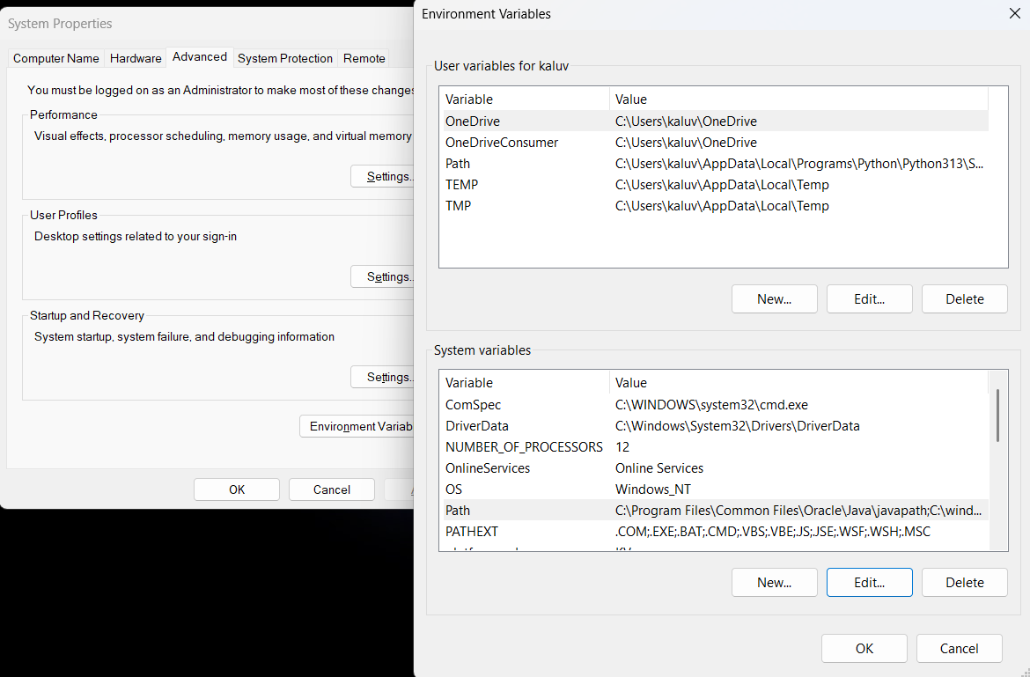

**Checking JDK Version: -**

* 1. **Open Command Prompt:**
* Presswin+R, typecmd, and press Enter.
  1. **Check Version:**
* Type java -version and press Enter.
* Type javac --version and press Enter.

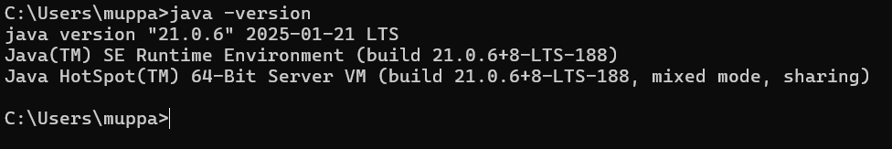

1. **Simple Java Program for printing Name, Class, Roll No, of a  
    Student :**

**CODE: -**

**public class details {**

**public static void main(String[]args) {**

**System.out.println("SRIMANTH");**

**System.out.println("CSE-C");**

**System.out.println("Roll-no:24228");**

**System.out.println("Amrita");**

**}**

**}**

**Output: -**

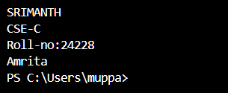

|  |  |  |
| --- | --- | --- |
| 1 | Syntax error | Semicolon added |
| 2 | Runtime error | Copied correct path |
| 3 | Name error | rectified |

**Week-2**

1) Java program for calculating simple interest:  
code:-  
import java.util.Scanner

class simpleinterest {

  public static void main(String[] args) {

    Scanner input = new Scanner(System.in);

    System.out.println("Enter the principal: ");

    double principal = input.nextDouble();

    System.out.println("Enter the rate: ");

    double rate = input.nextDouble();

    System.out.println("Enter the time: ");

    double time = input.nextDouble();

    double interest = (principal * time * rate) / 100;

    System.out.println("Simple Interest: " + interest)

    input.close();

  }Output:-  
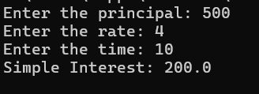  
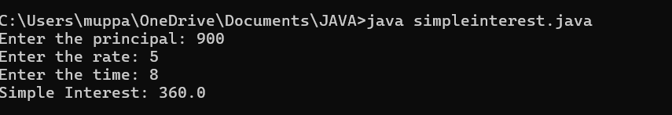

|  |  |  |  |
| --- | --- | --- | --- |
| **S.No** | **Error type** | **Reason for error** | **rectification** |
| **1** | **Runtime error** | **Incorrect path** | **Copied correct path** |
| **2** | **Syntax error** | **{ missing** | **{ added** |
| **3** | **Logical error** | **Wrong formula** | **Formula rectified** |

2)Java program for calculating area of rectangle:  
Code:-  
import java.util.Scanner;

class area {

public static void main(String[] args) {

Scanner input = new Scanner(System.in);

System.out.println("Enter the length of rectangle: ");

double length = input.nextDouble();

System.out.println("Enter the width of rectangle: ");

double width = input.nextDouble();

double Area;

Area = length*width;

System.out.println(" Area of rectangle: " + Area);

input.close();

}

}

**Output:-**

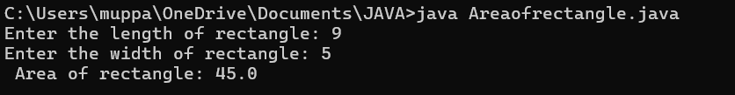

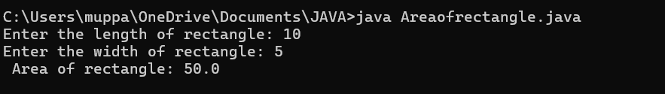

**Error:-**

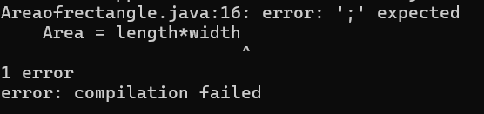

|  |  |  |  |
| --- | --- | --- | --- |
| **S.No** | **Error type** | **Reason for error** | **Rectification** |
| **1** | **Syntax error** | **Semi colon missing** | **Semi colon added** |
| **2** | **Missing import error** | **Import package missing** | **Import package added** |

3)Java program for calculating area of Triangle:

Code:-

import java.util.Scanner;

public class TriangleArea {

public static void main(String[] args) {

Scanner input = new Scanner(System.in);

System.out.print("Enter the base of the triangle: ");

double base = input.nextDouble();

System.out.print("Enter the height of the triangle: ");

double height = input.nextDouble();

double area = (base * height) / 2;

System.out.println("The area of the triangle is: " + area);

}

}  
**Output:-**

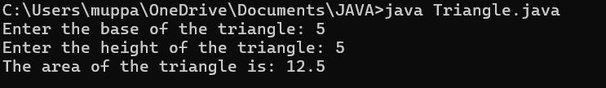

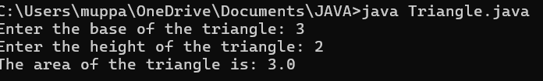

|  |  |  |  |
| --- | --- | --- | --- |
| **S.No** | **Error type** | **Reason for error** | **Rectification** |
| **1** | **Logical error** | **Incorrect formula** | **Formula rectified** |
| **2** | **Name error** | **Undeclared variable** | **Variable declared** |

4)Java program for calculating Fibonacci series:-

Code:-

import java.util.Scanner;

public class fb {

 public static void main(String[] args) {

  int Length;

  Scanner input = new Scanner(System.in); //create object

  System.out.print("Please enter length: ");

  Length = input.nextInt();

  int[] num = new int[Length];

  num[0] = 0;

  num[1] = 1;

  for (int i = 2; i < Length; i++) {

   num[i] = num[i - 1] + num[i - 2];

  }

  System.out.println("Fibonacci Series: ");

  for (int i = 0; i < Length; i++) {

   System.out.print(num[i] + " ");

}

}

}

**Output:-**

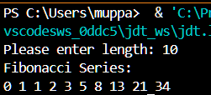

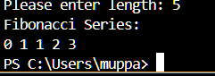

|  |  |  |  |
| --- | --- | --- | --- |
| **S.No** | **Error type** | **Reason for error** | **Rectification** |
| **1** | **Logical error** | **Incorrect formula** | **Formula rectified** |
| **2** | **Run-time error** | **Incorrect path** | **Added correct path** |

5)Write a java program to convert temperature from Fahrenheit

to Celsius:-

Code:-

import java.util.*;

class temp

{

public static void main(String args[])

{

Scanner sc = new Scanner(System.in); float c;

System.out.println("Enter celsius temperature:"); float f = sc.nextFloat();

c = (f-32)*5/9;

System.out.println("Fahrenheit temperatue is :"+c);

}

}

Output:-

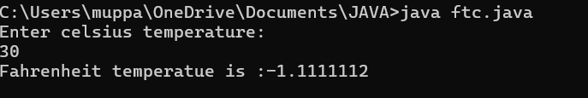

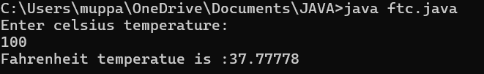

|  |  |  |  |
| --- | --- | --- | --- |
| **S.No** | **Error type** | **Reason for error** | **rectification** |
| **1** | **Syntax error** | **Missing ”** | **“ is added** |
| **2** | **Missing import error** | **Util package missing** | **Util package added** |

**WEEK-3**

PROGRAM-1

Aim:-

To create java program with following instructions

1.Create a class with name car

2. Create four attributes named car_color ,Car_brand,fuel_type,mileage

3. Create three methods named start(), stop(). Service()

4. Create three objects named car1,car2 and car3

Code:-

**i**mport java.util.*;

class car

{

public String Car_color;

public String Car_brand;

public String fuel_type;

public int mileage;

public void start()

{

System.out.println("Car Started:");

System.out.println("Car color is :"+Car_color);

System.out.println("Car Brand is:"+Car_brand);

System.out.println("Car fuel type is:"+fuel_type);

System.out.println("Car mileage is:"+mileage);

}

public void service()

{

System.out.println("Car Started:");

System.out.println("Car color is :"+Car_color);

System.out.println("Car Brand is:"+Car_brand);

System.out.println("Car fuel type is:"+fuel_type);

System.out.println("Car mileage is:"+mileage);

}

public void stop()

{

System.out.println("Car Started:");

System.out.println("Car color is :"+Car_color);

System.out.println("Car Brand is:"+Car_brand);

System.out.println("Car fuel type is:"+fuel_type);

System.out.println("Car mileage is:"+mileage);

}

public static void main(String args[])

{ System.out.println("\n Srimanth\n\n");

car car1 = new car();

car1.Car_color = "Black";

car1.Car_brand = "BMW";

car1.fuel_type = "Petrol";

car1.mileage = 100;

car1.start();

car car2 = new car();

car2.Car_color = "Grey";

car2.Car_brand = "Ferrari";

car2.fuel_type = "EV";

car2.mileage = 500;

car2.stop();

car car3 = new car();

car3.Car_color = "red";

car3.Car_brand = "Jaguar";

car3.fuel_type = "Diesel";

car3.mileage = 250;

car3.service();

}

OUTPUT:-

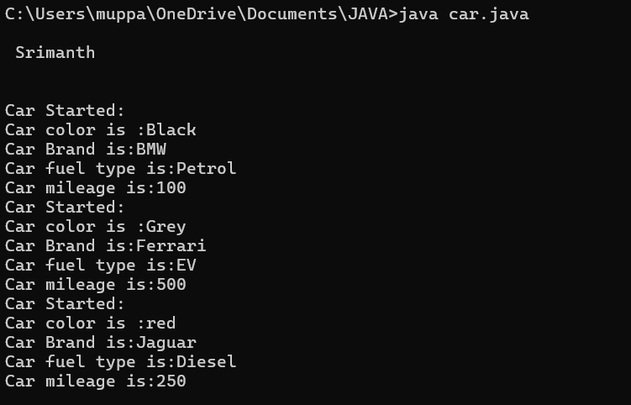

PROGRAM-2

AIM:-

To create a Bank Account class with methods

DEPOSIT and WITHDRAWAL

Code:-

class BankAccount

{

private double balance;

public BankAccount(double initialBalance)

{

if(initialBalance > 0)

{

this.balance = initialBalance;

}

else

{

this.balance = 0;

}

}

public void deposit(double amount)

{

if(amount>0)

{

balance = balance+amount;

System.out.println("Deposited ₹:"+amount);

}

else

{

System.out.println("Amount deposited must be positive");

}

}

public double getBalance()

{

return balance;

}

}

public class Main1

{

public static void main(String args[])

{

BankAccount account = new BankAccount(1000);

account.deposit(1500);

System.out.println("Current Balance is:"+account.getBalance());

}

}

OUTPUT:-

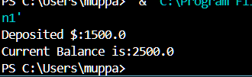

**WEEK-4**

**PROGRAM:-1**

**Aim:-**

ToWrite a java program with class named book. the class should contain various attributes such as title , author ,year of obligation .it should also contain a constructer with parameters which initialised title , author , year of obligation.

CODE:-

class Book {

String title;

String author;

int yearOfPublication;

public Book(String title, String author, int yearOfPublication) {

this.title = title;

this.author = author;

this.yearOfPublication = yearOfPublication;

}

public void displayDetails() {

System.out.println("Title: " + title);

System.out.println("Author: " + author);

System.out.println("Year of Publication: " + yearOfPublication);

}

public static void main(String[] args) {

Book book1 = new Book("Doomsday", "Schott", 1999);

Book1.displayDetails();

}

public static void main(String[] args) {

Book book2 = new Book("Breaking Bad", "Mr.white", 1973);

Book2.displayDetails();

}

}

**OUTPUT:-**

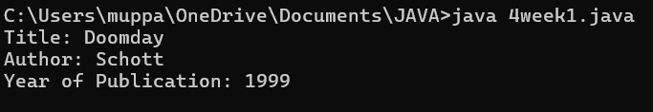

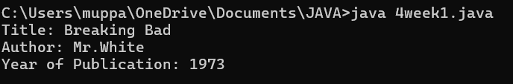

|  |  |
| --- | --- |
| **Code Error** | **Code Rectififcation** |
| **1.Two public classes should not be saved in same file** | **1.Two public classes should be saved in different files** |

**IMPORTANT POINTS:-**

1. While defining two classes for a code, we must be sure that we save both the classes in separate files.
2. While defining a method we should also define a function to call that method.

**CLASS DIAGRAM:-**

|  |
| --- |
| Book  - Title: String  - Author: String  - Year of publication: int  + Book(title: String,  Author: String;  Year of publication: int  + displayDetails( ): void |

**PROGRAM – 2:**

**AIM:-**

Create a java Program with class named myclass with static variable count of int type, initialized to zero and a constant variable “pi” of type double initialized to 3.14 as attributes of the class, ow define a constructor for “myclass” that increments the count variable each time an object of my class is created (count++), finally print the final values of count and pi variables create three objects.

**CODE:-**

public class myclass {

static int count = 0;

final double pi= 3.14;

public myclass() {

count++;

}

public static void main(String[] args) {

myclass object1 = new myclass();

myclass object2 = new myclass();

myclass object3 = new myclass();

System.out.println("count: " + count);

System.out.println("Value of pi: " + object1.pi);

System.out.println("Value of pi: "+ object2.pi);

System.out.println("Value of pi: "+ object3.pi);

}

}

**OUTPUT:-**

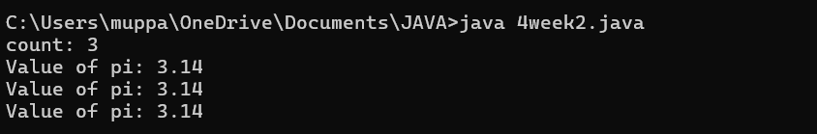

**ERROR TABLE:**

|  |  |
| --- | --- |
| **Code Error** | **Code rectification** |
| 1. Not Putting the semi-colon after calling a function, | 1. Put the semi-colon after calling a function. |

**IMPORTANT POINTS:-**

1. We must declare the initial value of the variable before declaring the final one.
2. Here the main objective is to increase the count according to the number of objects we make, i.e the count increases when the no.of objects are increasing.

**CLASS DIAGRAM:-**

|  |
| --- |
| myclass   * Count: int * Pi: double   + myclass( )  + main(args: String[]): void |

WEEK-5

**AIM: Create a calculator using the operations including addition, subtraction**

**Multiplication and division using multilevel inheritance and display the desired**

**Output**

**Class Diagram:**

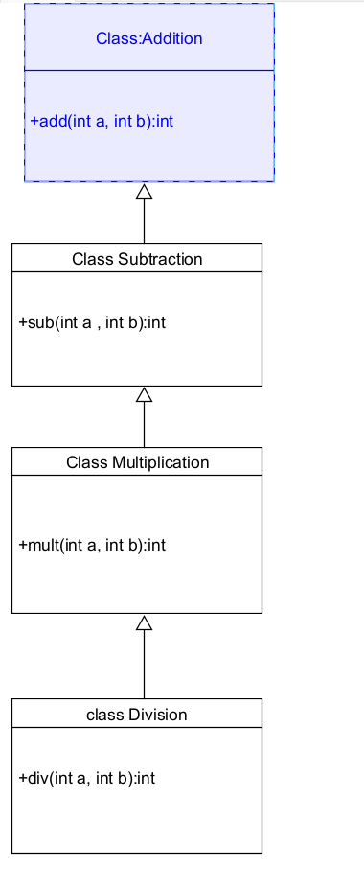

**Code:-**

**class addition**

**{**

**public int add(int a, int b)**

**{**

**int addition = a+b;**

**return addition;**

**}**

**}**

**class subtraction extends addition**

**{**

**public int sub(int a, int b)**

**{**

**int subtraction = a-b;**

**return subtraction;**

**}**

**}**

**class multiplication extends subtraction**

**{**

**public int mult(int a, int b)**

**{**

**int multiplication = a*b;**

**return multiplication;**

**}**

**}**

**class division extends multiplication**

**{**

**public int div(int a,int b)**

**{**

**int division = a/b;**

**return division;**

**}**

**}**

**class calculator**

**{**

**public static void main(String args[])**

**{**

**division cal = new division();**

**System.out.println("Addition is:"+ cal.add(8,7));**

**System.out.println ("Subtraction is:"+cal.sub(5,2));**

**System.out.println("Multiplication is:"+cal.mult(20,8));**

**System.out.println("Division is:"+cal.div(16,8));**

**}**

**}**

**Output:-**

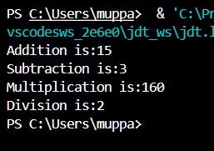

**Error Table:-**

|  |  |  |  |
| --- | --- | --- | --- |
| **S.No** | **Error Type** | **Cause** | **Rectification** |
| **1** | **Constructor error** | **Invalid name to method** | **Defined class name** |
| **2** | **Syntax error** | **Expected ‘S’ instead of s** | **Added S to string** |
| **3** | **Logical error** | **Incorrect arithmetic**  **operation** | **Correct operation**  **rectified** |

**Negative Case:-**

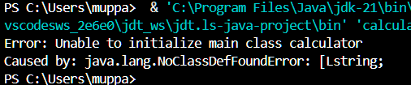

**2.**

**Aim: A vehicle rental company wants to develop a system that maintains**

**Information about different types of vehicles available for rent**

**The Company rents out cars, bikes and truck and they need a program to**

**Store details about each vehicle, such as brand and speed**

**Cars should have an additional property: number of doors**

**Bikes should have a property indicating whether they have gears or not**

**The system should also include a function to display details about each vehicle**

**And indicate when a vehicle is starting**

**Class diagram**

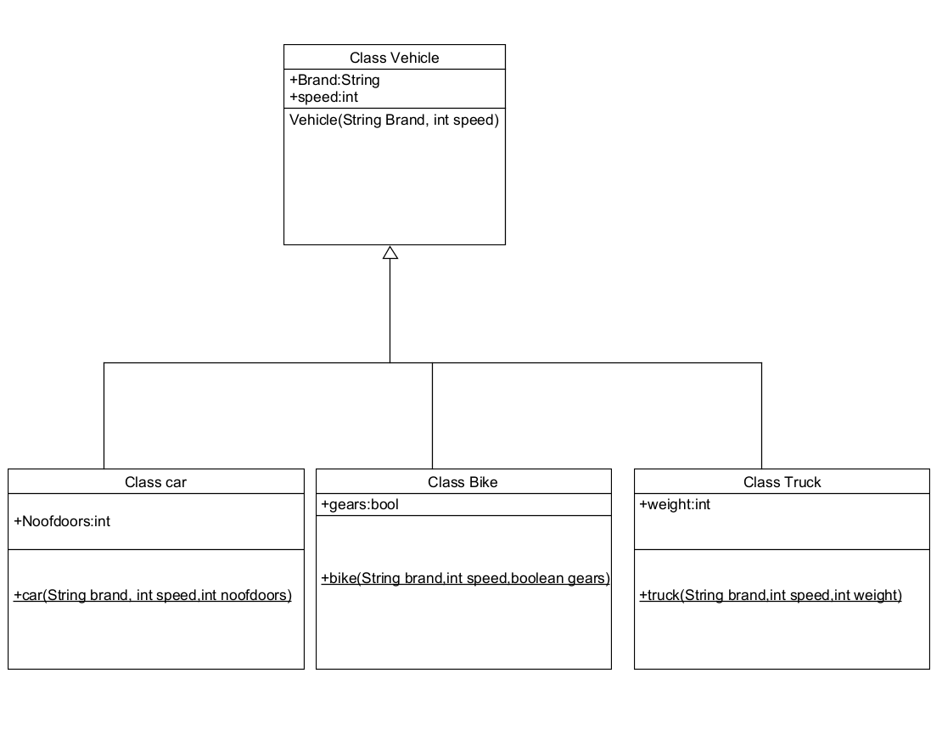

**Code:-**

**class vehicle{**

**String brand;**

**int speed;**

**public vehicle(String brand,int speed){**

**this.brand=brand;**

**this.speed=speed;**

**}**

**public static void main(String[] args) {**

**car obj1=new car("bmw",45,4);**

**bike obj2=new bike("royal",120,true);**

**truck obj3=new truck("mahindra",70,100);**

**}**

**}**

**class car extends vehicle{**

**int noofdoors;**

**public car(String brand, int speed,int noofdoors) {**

**super(brand, speed);**

**this.noofdoors=noofdoors;**

**System.out.println("Brand of car is:"+brand);**

**System.out.println("Speed of car is:"+speed);**

**System.out.println("no of doors of car:"+noofdoors);**

**}**

**}**

**class bike extends vehicle{**

**boolean gears;**

**public bike(String brand,int speed,boolean gears){**

**super(brand, speed);**

**this.gears=gears;**

**System.out.println("Brand of bike is:"+brand);**

**System.out.println("Speed of bike is:"+speed);**

**System.out.println("Gears of bike:"+gears);**

**}**

**}**

**class truck extends vehicle{**

**int weight;**

**public truck(String brand,int speed,int weight){**

**super(brand,speed);**

**this.weight=weight;**

**System.out.println("Brand name is:"+brand);**

**System.out.println("Speed of Truck is:"+speed);**

**System.out.println("Weight of load is"+weight);**

**}**

**}**

**Output:-**

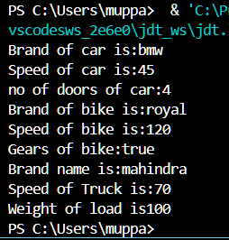

**Error Table:**

|  |  |  |  |
| --- | --- | --- | --- |
| **S No** | **Error Type** | **Cause** | **Rectification** |
| **1** | **Syntax Error** | **Semicolon missing** | **Added ;** |
| **2** |  |  |  |
| **3** |  |  |  |

**Negative Case:-**

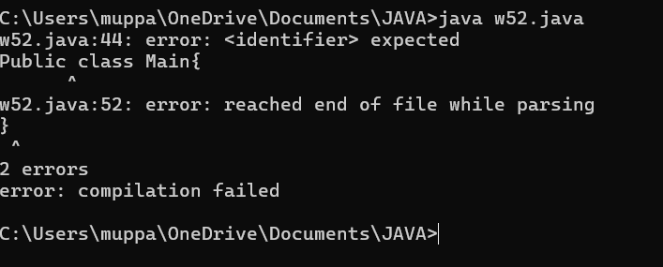

**Important Points:-**

**Hierarchical Inheritence:**

**This is a type of inheritance occurs when multiple subclasses inherit from a**

**Single parent class**

**WEEK - 6**

1. **Aim : Write a Java program to create a Vehicle class with a method displayInfo(). Override this method in the Car subclass to provide specific information about a car.**

**Program :**

class vehicle{

    String company;

    String model;

    String fuel;

    int capacity;

    void displayInfo(String company,String model,String fuel,int capacity){

        System.out.println("The details of vehicle: ");

        this.company=company;

        this.model=model;

        this.fuel=fuel;

        this.capacity=capacity;

    }

}

class car extends vehicle{

    void displayInfo(String company,String model,String fuel,int capacity){

        System.out.println("Company: "+company);

        System.out.println("Model: "+model);

        System.out.println("Fuel: "+fuel);

        System.out.println("Capacity: "+capacity);

    }

}

class poly1{

    public static void main(String[] args){

        car car1=new car();

         car1.displayInfo("BMW","A6","Diesel",4);

    }

}

**OUTPUT :**

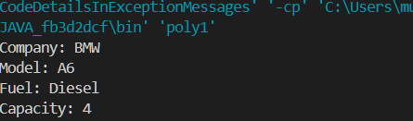

**ERRORS :**

|  |  |  |  |
| --- | --- | --- | --- |
| **S.No** | **Error type** | **Reason for error** | **Rectification** |
| 1 | Syntax error | [] is missed | [] is added |
| 2 | Logical error | Incorrect logic | Correct logic |

**2) Aim :** A college is developing an automated admission system that verifies students' eligibility for undergraduate (UG) and postgraduate (PG) programs. Each program has different eligibility criteria based on the students' percentage in their previous qualifications.

(i)UG admissions require a minimum of 60%.

(ii)PG admissions require a minimum of 70%

**Program :**

class College{

    String name;

    int percentage;

    void geteligibility(String name,int percentage){

        this.name=name;

        this.percentage=percentage;

    }

}

class UG extends College{

    void geteligibility(String name,int percentage){

        if (percentage>=60){

            System.out.println(name+" is eligible");

        }

        else{

            System.out.println(name+" is not eligible");

        }

    }

}

class PG extends College{

    void geteligibility(String name,int percentage){

        if (percentage>=70){

            System.out.println(name+" is eligible");

        }

        else{

            System.out.println(name+" is not eligible");

        }

    }

}

class poly2{

    public static void main(String[] args){

        UG ug=new UG();

        ug.geteligibility("Person-1",40);

        PG pg=new PG();

        pg.geteligibility("Person-2",80);

    }

}

**OUPUT :**

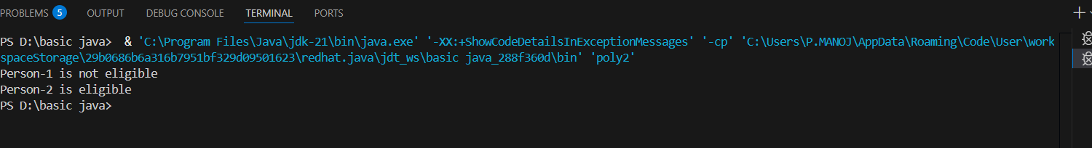

**ERROR :**

|  |  |  |  |
| --- | --- | --- | --- |
| **S.No** | **Error type** | **Reason for error** | **Rectification** |
| 1 | syntax error | String forgot in main function | String is added |
| 2 | Logical error | Incorrect logic | Correct logic |

**3) Aim :** Create a Calculator class with overloaded methods to perform addition:

(i) Add two integers.

(ii) Add two doubles.

(iii) Add three integers.

**Program :**

class Calcee{

    public int add(int a,int b){

        return a+b;

    }

    public double add(double a,double b){

        return a+b;

    }

    public int add(int a,int b,int c){

        return a+b+c;

    }

}

class poly3{

    public static void main(String[] args){

        Calcee C1=new Calcee();

        System.out.println("Sum of 2 and 5 is: "+C1.add(2,5));

        System.out.println("Sum of 3.2 and 6.5 is: "+C1.add(3.2,6.5));

        System.out.println("Sum of 2,5 and 3 is: "+C1.add(2,5,3));

    }

}

**OUTPUT :**

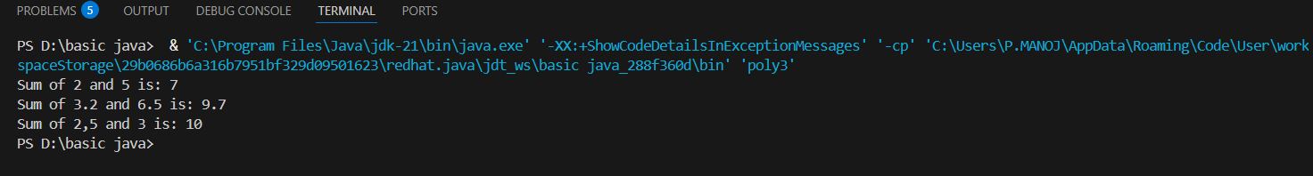

**ERROR :**

|  |  |  |  |
| --- | --- | --- | --- |
| **S.No** | **Error type** | **Reason for error** | **Rectification** |
| 1 | syntax error | String forgot in main function | String is added |
| 2 | Logical error | Incorrect logic | Correct logic |

**4)Aim :** Create a Shape class with a method calculateArea() that is overloaded for different shapes (e.g., square, rectangle). Then, create a subclass Circle that overrides the calculateArea() method for a circle.

**Program :**

class Shape { // class shape

    void calculateArea( int a) { // method 1

        System.out.println("The area of Square is :" + (a*a) );

    }

    void calculateArea(int a , int b) { // method 2

        System.out.println("The area of rectangle is :" + (a*b));

    }

}

class circle extends Shape { // inheritance class

    void calculateArea(double a){ // method overloading

        System.out.println("The area of circle is :" + (3.14*a*a));

  } }

class main { // main program

    public static void main(String[] args) {

        // creating objects for class

        Shape s = new Shape();

        circle c = new circle();

        // calling methods

        s.calculateArea(4);

        System.out.println("    ");

        s.calculateArea(4, 5);

        System.out.println("    ");

        c.calculateArea(2);

    }

}

**OUTPUT :**

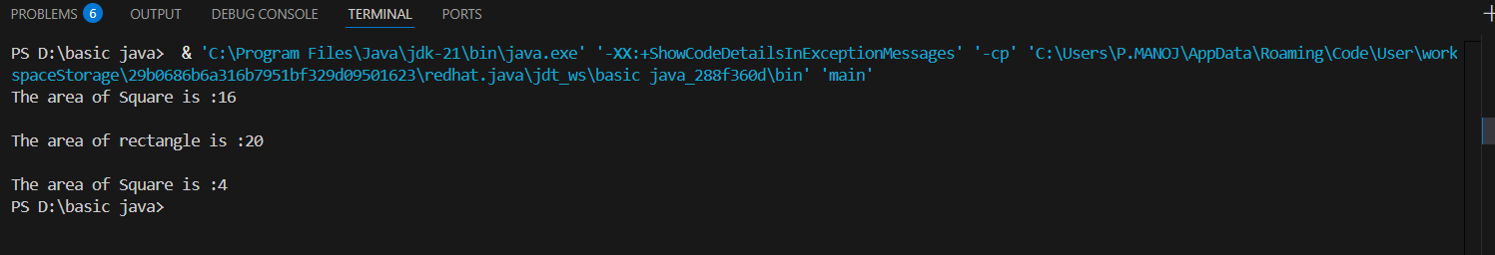

**ERRORS :**

|  |  |  |  |
| --- | --- | --- | --- |
| **S.No** | **Error type** | **Reason for error** | **Rectification** |
| 1 | Syntax error | ; is missed | ; is added |
| 2 | Logical error | Incorrect logic | Correct logic |